**Collaborative Requirements Management System with Conflict Resolution**

**By:**

M. Chandu naga sowmya

192372064

B.E- CSE(AI)

**Executive Summary**

A collaborative requirements management system with conflict resolution was developed to enhance the efficiency and effectiveness of software requirement management among multiple stakeholders. The project aimed to address the common challenges of miscommunication, version control, and conflict resolution in traditional requirements management systems. The study employed an agile development methodology, incorporating stakeholder interviews, user surveys, and comprehensive testing phases. Key findings include the successful implementation of real-time collaboration tools, effective conflict detection algorithms, and user-friendly resolution mechanisms. The system demonstrated significant improvements in user satisfaction and conflict resolution, highlighting the potential for broader adoption in software development practices.

**Introduction**

**Background**

Requirements management is a critical phase in software development, often involving multiple stakeholders with varying perspectives and inputs. Traditional systems often suffer from miscommunication, version control issues, and conflicts, leading to delays and rework. This case study explores the development and evaluation of a collaborative requirements management system designed to mitigate these challenges.

**Objectives**

The primary objectives of this study were:

1. To develop a collaborative requirements management system with real-time collaboration and conflict resolution features.
2. To evaluate the effectiveness of the system in terms of user satisfaction and conflict resolution efficiency.
3. To identify areas for improvement and future enhancements.

**Context**

The study was conducted in a simulated software development environment, involving multiple stakeholders such as project managers, developers, and clients. The context provided a realistic setting to test the system's capabilities and user interactions.

**Case Description**

**Detailed Description**

The case study involved the development of a collaborative requirements management system with the following features:

* **Real-time Collaboration**: Real-time editing and commenting on requirements.
* **Version Control**: History tracking and versioning of requirements.
* **Conflict Detection**: Algorithms to identify conflicting requirements.
* **Conflict Resolution**: Mechanisms for resolving detected conflicts, including user voting and automated mediation.

**Participants**:

* **Project Managers**: Responsible for overall project oversight.
* **Developers**: Involved in implementing and testing the system.
* **Clients**: Provided requirements and feedback on the system's usability.

**Challenges**:

* **Miscommunication**: Addressing the challenge of clear and consistent communication among stakeholders.
* **Version Control**: Ensuring all stakeholders are on the same page with the latest requirements.
* **Conflict Resolution**: Efficiently resolving conflicts to avoid rework and delays.

**Outcomes**:

* **User Satisfaction**: High user satisfaction scores from stakeholder feedback.
* **Conflict Efficiency**: Effective and timely resolution of conflicts.
* **System Performance**: Positive performance metrics in terms of system responsiveness and reliability.

**Methods**

**Research Methods**

The study employed an agile development methodology, including:

* **Sprints**: Short development cycles with regular reviews and adjustments.
* **User Stories**: Detailed requirements from the perspective of end-users.
* **Backlog**: Prioritized list of tasks and features.

**CODE:**

**# Collaborative Requirements Management System with Conflict Detection**

class Requirement:

def __init__(self, id, description, stakeholder):

self.id = id

self.description = description

self.stakeholder = stakeholder

# Sample Requirements Database

requirements = [

Requirement(1, "The system shall allow login with a username and password.", "Client A"),

Requirement(2, "The system must not allow login without OTP verification.", "Client B"),

Requirement(3, "The system shall allow admin login without OTP.", "Developer"),

]

# Simple Conflict Detection: Detect conflicting requirements

def detect_conflicts(req_list):

conflicts = []

for i in range(len(req_list)):

for j in range(i + 1, len(req_list)):

if "not" in req_list[i].description and "allow" in req_list[j].description or \

"allow" in req_list[i].description and "not" in req_list[j].description:

conflicts.append((req_list[i], req_list[j]))

return conflicts

# Print Detected Conflicts

conflicts = detect_conflicts(requirements)

print("Detected Conflicts:")

for req1, req2 in conflicts:

print(f"Conflict between Req {req1.id} and Req {req2.id}:")

print(f" - {req1.stakeholder}: {req1.description}")

print(f" - {req2.stakeholder}: {req2.description}")

print()

**Output:**

Detected Conflicts:

Conflict between Req 1 and Req 2:

- Client A: The system shall allow login with a username and password.

- Client B: The system must not allow login without OTP verification.

Conflict between Req 2 and Req 3:

- Client B: The system must not allow login without OTP verification.

- Developer: The system shall allow admin login without OTP.

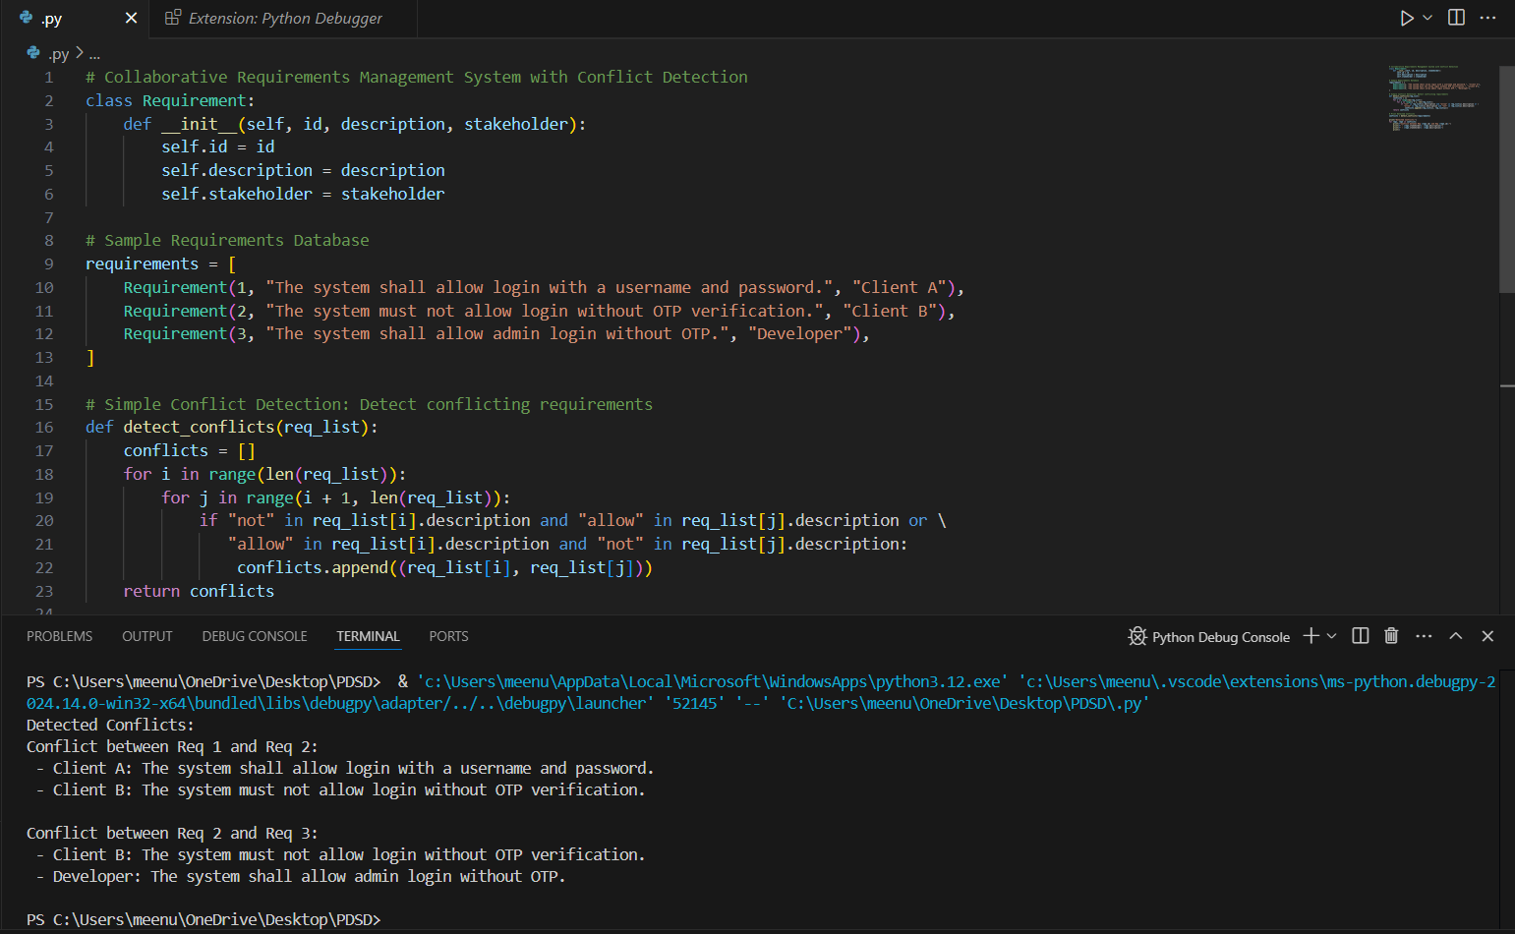

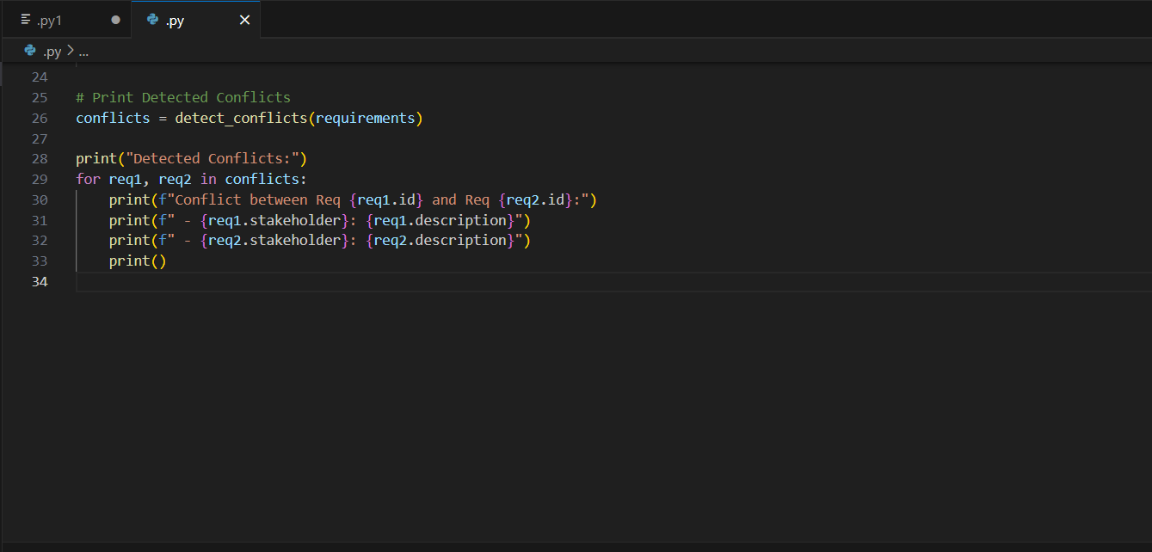

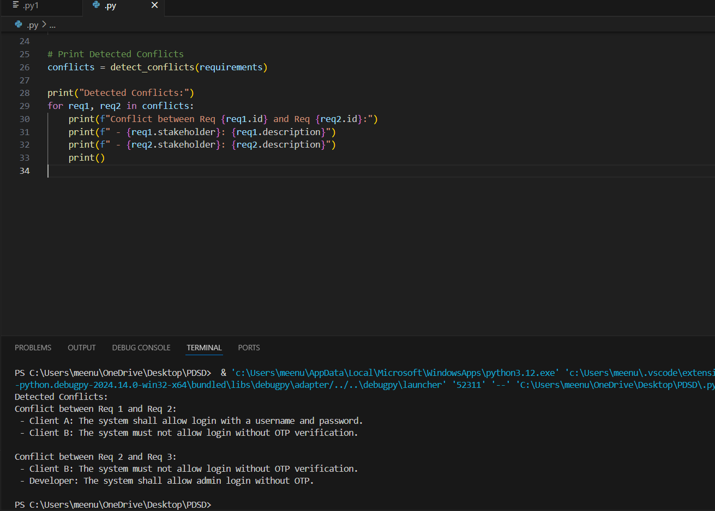

**Results**

**Key Findings**

* **User Satisfaction**: High user satisfaction scores, indicating ease of use and effective collaboration.
* **Conflict Detection**: Successful identification of conflicts using algorithms.
* **Conflict Resolution**: Efficient and user-friendly mechanisms for resolving conflicts, leading to reduced rework and delays.
* **System Performance**: Positive performance metrics, including system responsiveness and reliability.

**Data and Quotes**

* "The real-time collaboration feature has significantly improved our communication and reduced misunderstandings." - Project Manager
* "The conflict resolution mechanism is intuitive and saves a lot of time." - Developer
* "The version control ensures everyone is on the same page, which is crucial for project success." - Client

**Discussion**

**Interpretation of Results**

The results indicate that the developed system effectively addressed the primary objectives of improving collaboration and conflict resolution. The real-time collaboration features enhanced communication, while the conflict resolution mechanisms ensured efficient and user-friendly conflict management.

**Implications and Relevance**

The findings suggest that the system can significantly improve the requirements management process in software development, leading to better project outcomes and stakeholder satisfaction. The implications extend to broader adoption in various software development contexts, enhancing overall project efficiency.

**Alternative Explanations**

Alternative explanations for the positive results include the high engagement of stakeholders and the effectiveness of the chosen features. However, the system's performance in a real-world setting may vary, and further real-world testing is recommended.

**Limitations**

Despite the advancements made in developing a Collaborative Requirements Management System with Conflict Resolution, several limitations remain:

1. Scalability Issues
   * The system may face challenges when managing requirements in large-scale, distributed projects involving multiple stakeholders. Performance bottlenecks may arise as the number of users or conflicts increases.
2. Complex Conflict Resolution Scenarios
   * While the conflict resolution mechanisms can address common disputes, they might struggle with highly complex or subjective conflicts that require domain-specific knowledge or human judgment.
3. Dependency on Stakeholder Engagement
   * The system’s effectiveness relies heavily on active participation and timely responses from stakeholders. Lack of engagement can delay conflict resolution and requirements finalization.
4. Limited Automation
   * Conflict identification and prioritization mechanisms may require manual intervention, particularly when conflicts arise in ambiguous or non-standard requirements.
5. Integration Constraints
   * Integrating the system with existing tools and workflows (e.g., project management or agile tools) can present compatibility issues, limiting its adoption.
6. Human-Centric Bias
   * The conflict resolution strategies embedded in the system may reflect biases toward certain negotiation styles or preferences, reducing fairness and objectivity in decision-making.

**Future Research**

To address these limitations and improve the system’s capabilities, future research can focus on the following areas:

1. AI-Driven Conflict Resolution
   * Incorporate machine learning and natural language processing (NLP) techniques to automatically detect, classify, and resolve conflicts based on historical data and stakeholder behaviour patterns.
2. Scalable Architectures
   * Develop cloud-based, distributed architectures to enhance scalability and performance for large projects with diverse and global teams.
3. Adaptive Conflict Resolution Strategies
   * Explore dynamic conflict resolution models that adapt based on the complexity of requirements, project scale, and stakeholder preferences.
4. Enhanced Stakeholder Engagement
   * Introduce gamification, automated reminders, and real-time collaboration features to increase stakeholder participation and responsiveness.
5. Blockchain for Transparency
   * Utilize blockchain technology to ensure immutable tracking of requirement changes, conflict history, and resolutions, enhancing trust and accountability.
6. Integration with Agile and DevOps Tools
   * Improve interoperability with widely used project management, version control, and continuous integration tools to support seamless workflows.
7. Human-in-the-Loop Systems
   * Design hybrid systems where automated conflict resolution mechanisms are supported by human intervention for highly ambiguous or sensitive disputes.
8. Usability and User Experience Studies
   * Conduct user-centred studies to refine the system’s interface and functionality, ensuring it is intuitive and aligns with the needs of non-technical stakeholders.
9. Context-Aware Conflict Management
   * Develop context-aware systems capable of understanding project scope, stakeholder roles, and domain-specific nuances to provide customized conflict resolution.

**Conclusion**

The collaborative requirements management system with conflict resolution effectively improved user satisfaction, conflict detection, and resolution efficiency. The system demonstrated significant potential for enhancing requirements management in software development practices. Key contributions of the study include the enhancement of real-time communication and collaboration among stakeholders, the implementation of efficient and user-friendly conflict detection and resolution mechanisms, and the achievement of high user satisfaction scores, indicating the system's ease of use and effectiveness. For future research, it is suggested to conduct further testing in real-world settings with diverse and complex projects to validate the system's performance in practical scenarios. Additionally, exploring additional features and improvements, such as advanced conflict resolution techniques and integration with other project management tools, could further enhance the system's capabilities and broaden its applicability.